Online Shopping System: FootFusion

Use-Case Specification: Buyer Manage Order

Version <1.0>

Revision History
Date | Version | Description | Author
<21/12/2024> | <1.0> | Final Draft | Trần Đức Anh

Table of Contents
1. Use-Case Name 4
1.1 Brief Description 4
1.1.1. Search and View Order 4
1.1.2. Create Order 4
1.1.3. Cancel Order 4
2. Flow of Events 4
2.1 Basic Flow 4
2.1.1. Search and View Order 4
2.1.2. Create Order 4
2.1.3. Cancel Order 5
2.2 Alternative Flows 6
3. Special Requirements 6
4. Preconditions 6
5. Postconditions 6
6. Extension Points 6

7. Prototype 7

Use-Case Specification: Buyer Manage Order

Use-Case Name

Brief Description
    - Search and View Order:
As Seller, users in this situation are buyers who can search and view any order (products) that they want to buy on the website of FootFusion’s system.
    - Create Order:
This use-case allows users (buyers) with buyer accounts to create an order.
    - Cancel Order:
This use-case allows users (buyers) with buyer accounts to cancel an order.

Flow of Events

Basic Flow
2.1.1. Search and View Order:
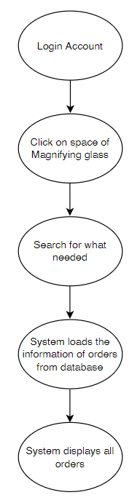
2.1.2. Create Order:
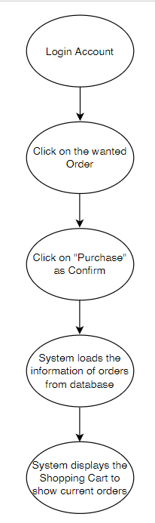
2.1.3. Cancel Order:
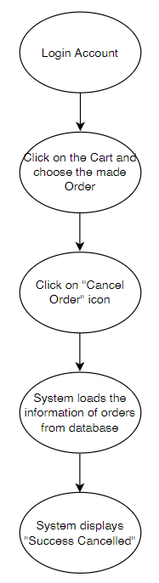

Alternative Flows

There is no alternative flow.

Special Requirements
None.

Preconditions
Users have to have account with their personal information to wander on the website.

Postconditions
The order they create has to be appeared.
The canceling order has to be deleted when they want to.

Extension Points
None.

Prototype

Search and View Order:
Figure 1: Login + Click on space of Magnifying glass to search Order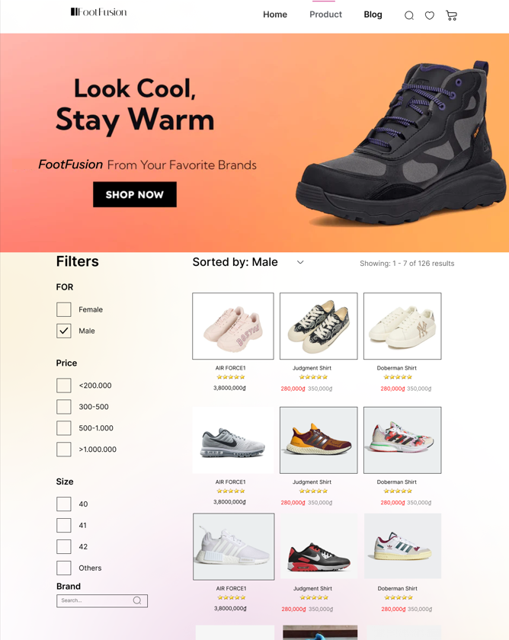



Figure 2: After searching name of Order, system will display the information of Order
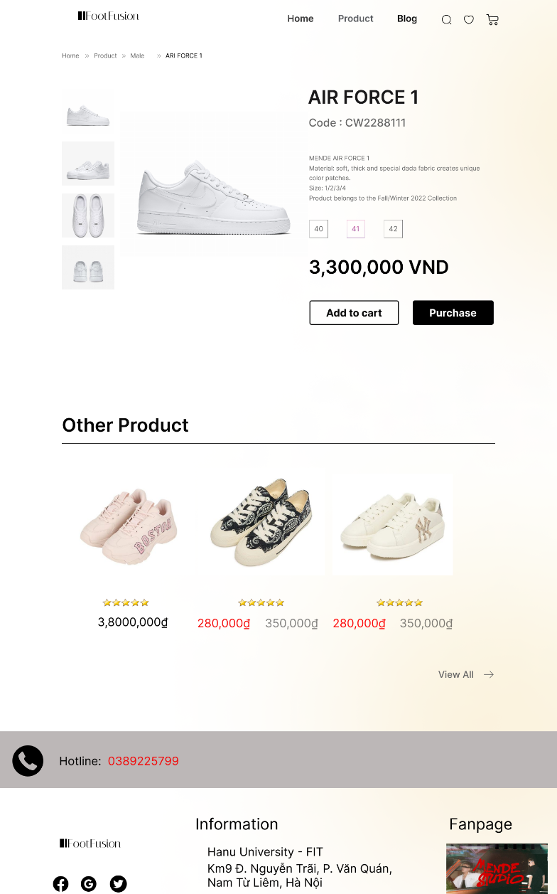

Create Order:
Figure 1: Click on the Order user want to buy + Click on “Purchase”
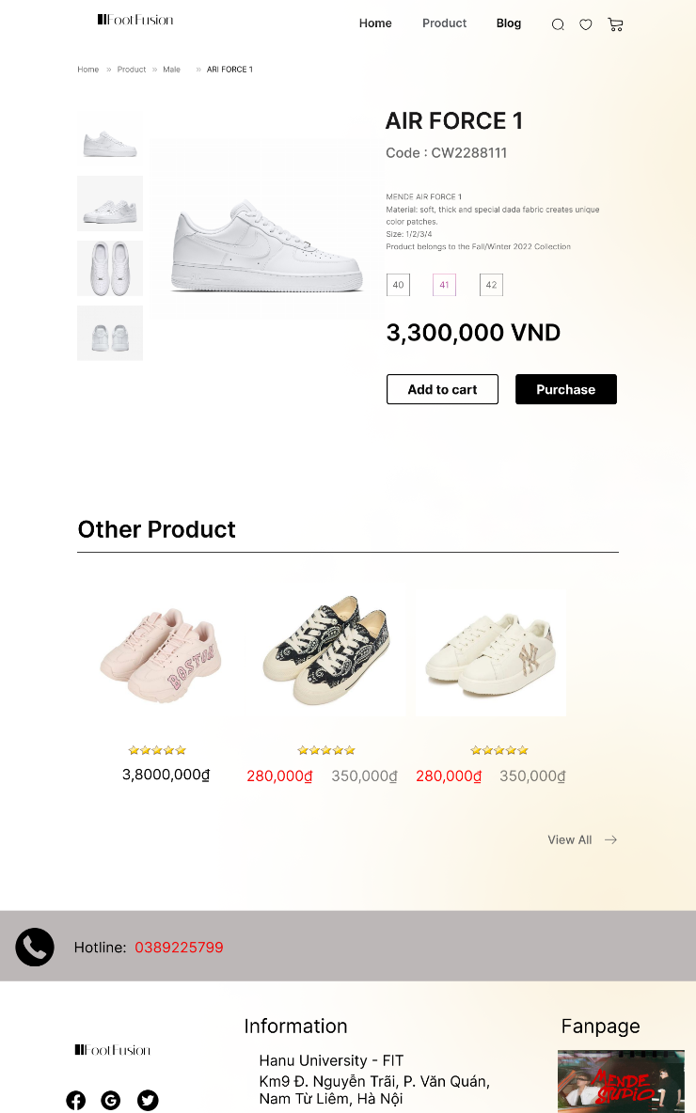

Figure 2: System will load the information of the Orders, then display the Shopping Cart to show current Orders
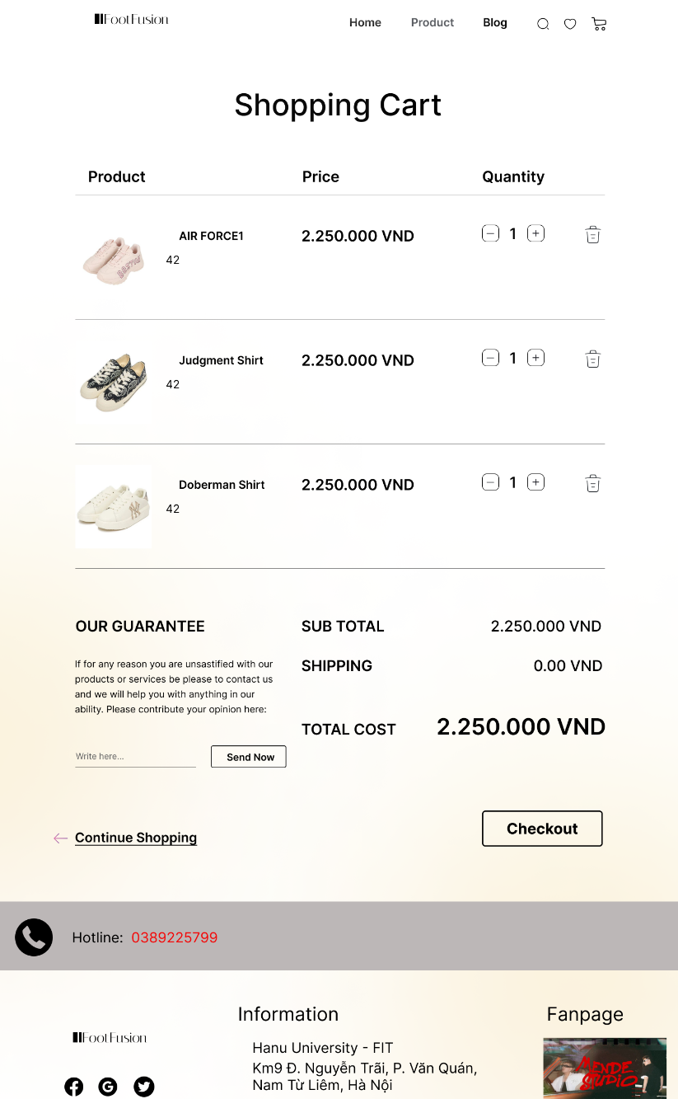

Cancel Order:

Figure 1: Click on the Cart to check the current orders


Figure 2: Click on the made Order that want to be deleted
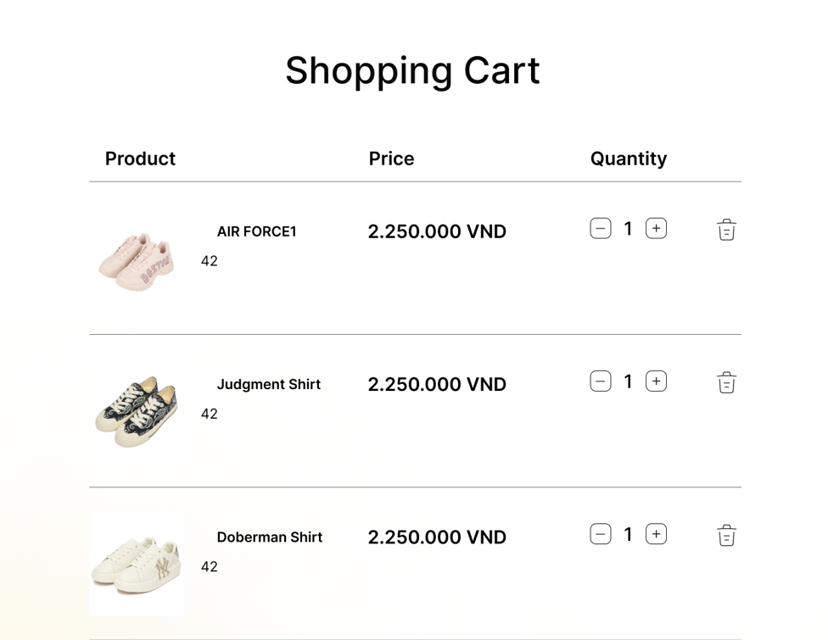

Figure 3: Click on the “Cancel Delete” icon


Figure 4: System loads the information, then shows the “Successful Message”
